Martin Hughes - It’s about Time!

We want to improve

We learn new stuff

We need time to share/embed

We can’t find time

Continually looping cycle

We take great care of kids … but often don’t take great care of ourselves

Our challenge ….

The only thing that is constant … is change

Schools are dynamic, chaotic, and changing

Secret is better time management

If we can’t manage ourselves we can’t manage anything

If you focus on results, you will never change (improve), If you focus on change (improvement), you will get results. Jack Dixon

Solutions that work for teachers and students

We have to look after ourselves

Are you too busy to improve?

See lego pic below

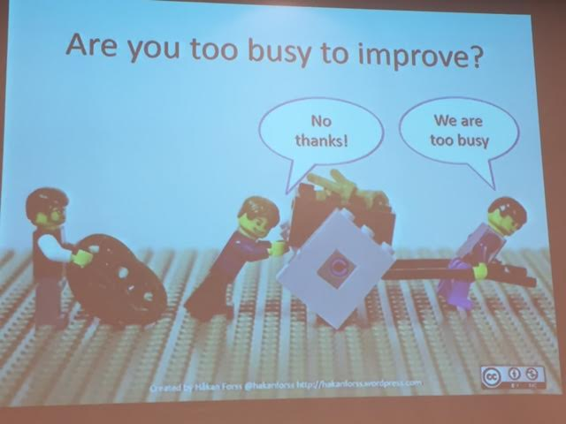

Shorter summer holidays??

We forget what was not going well over the summer holidays and come back and do them all over again.

**todays world**

finding

sharing

collecting

contributing

playing remixing

anytime anywhere

Universal Skills for Learners (google the picture)

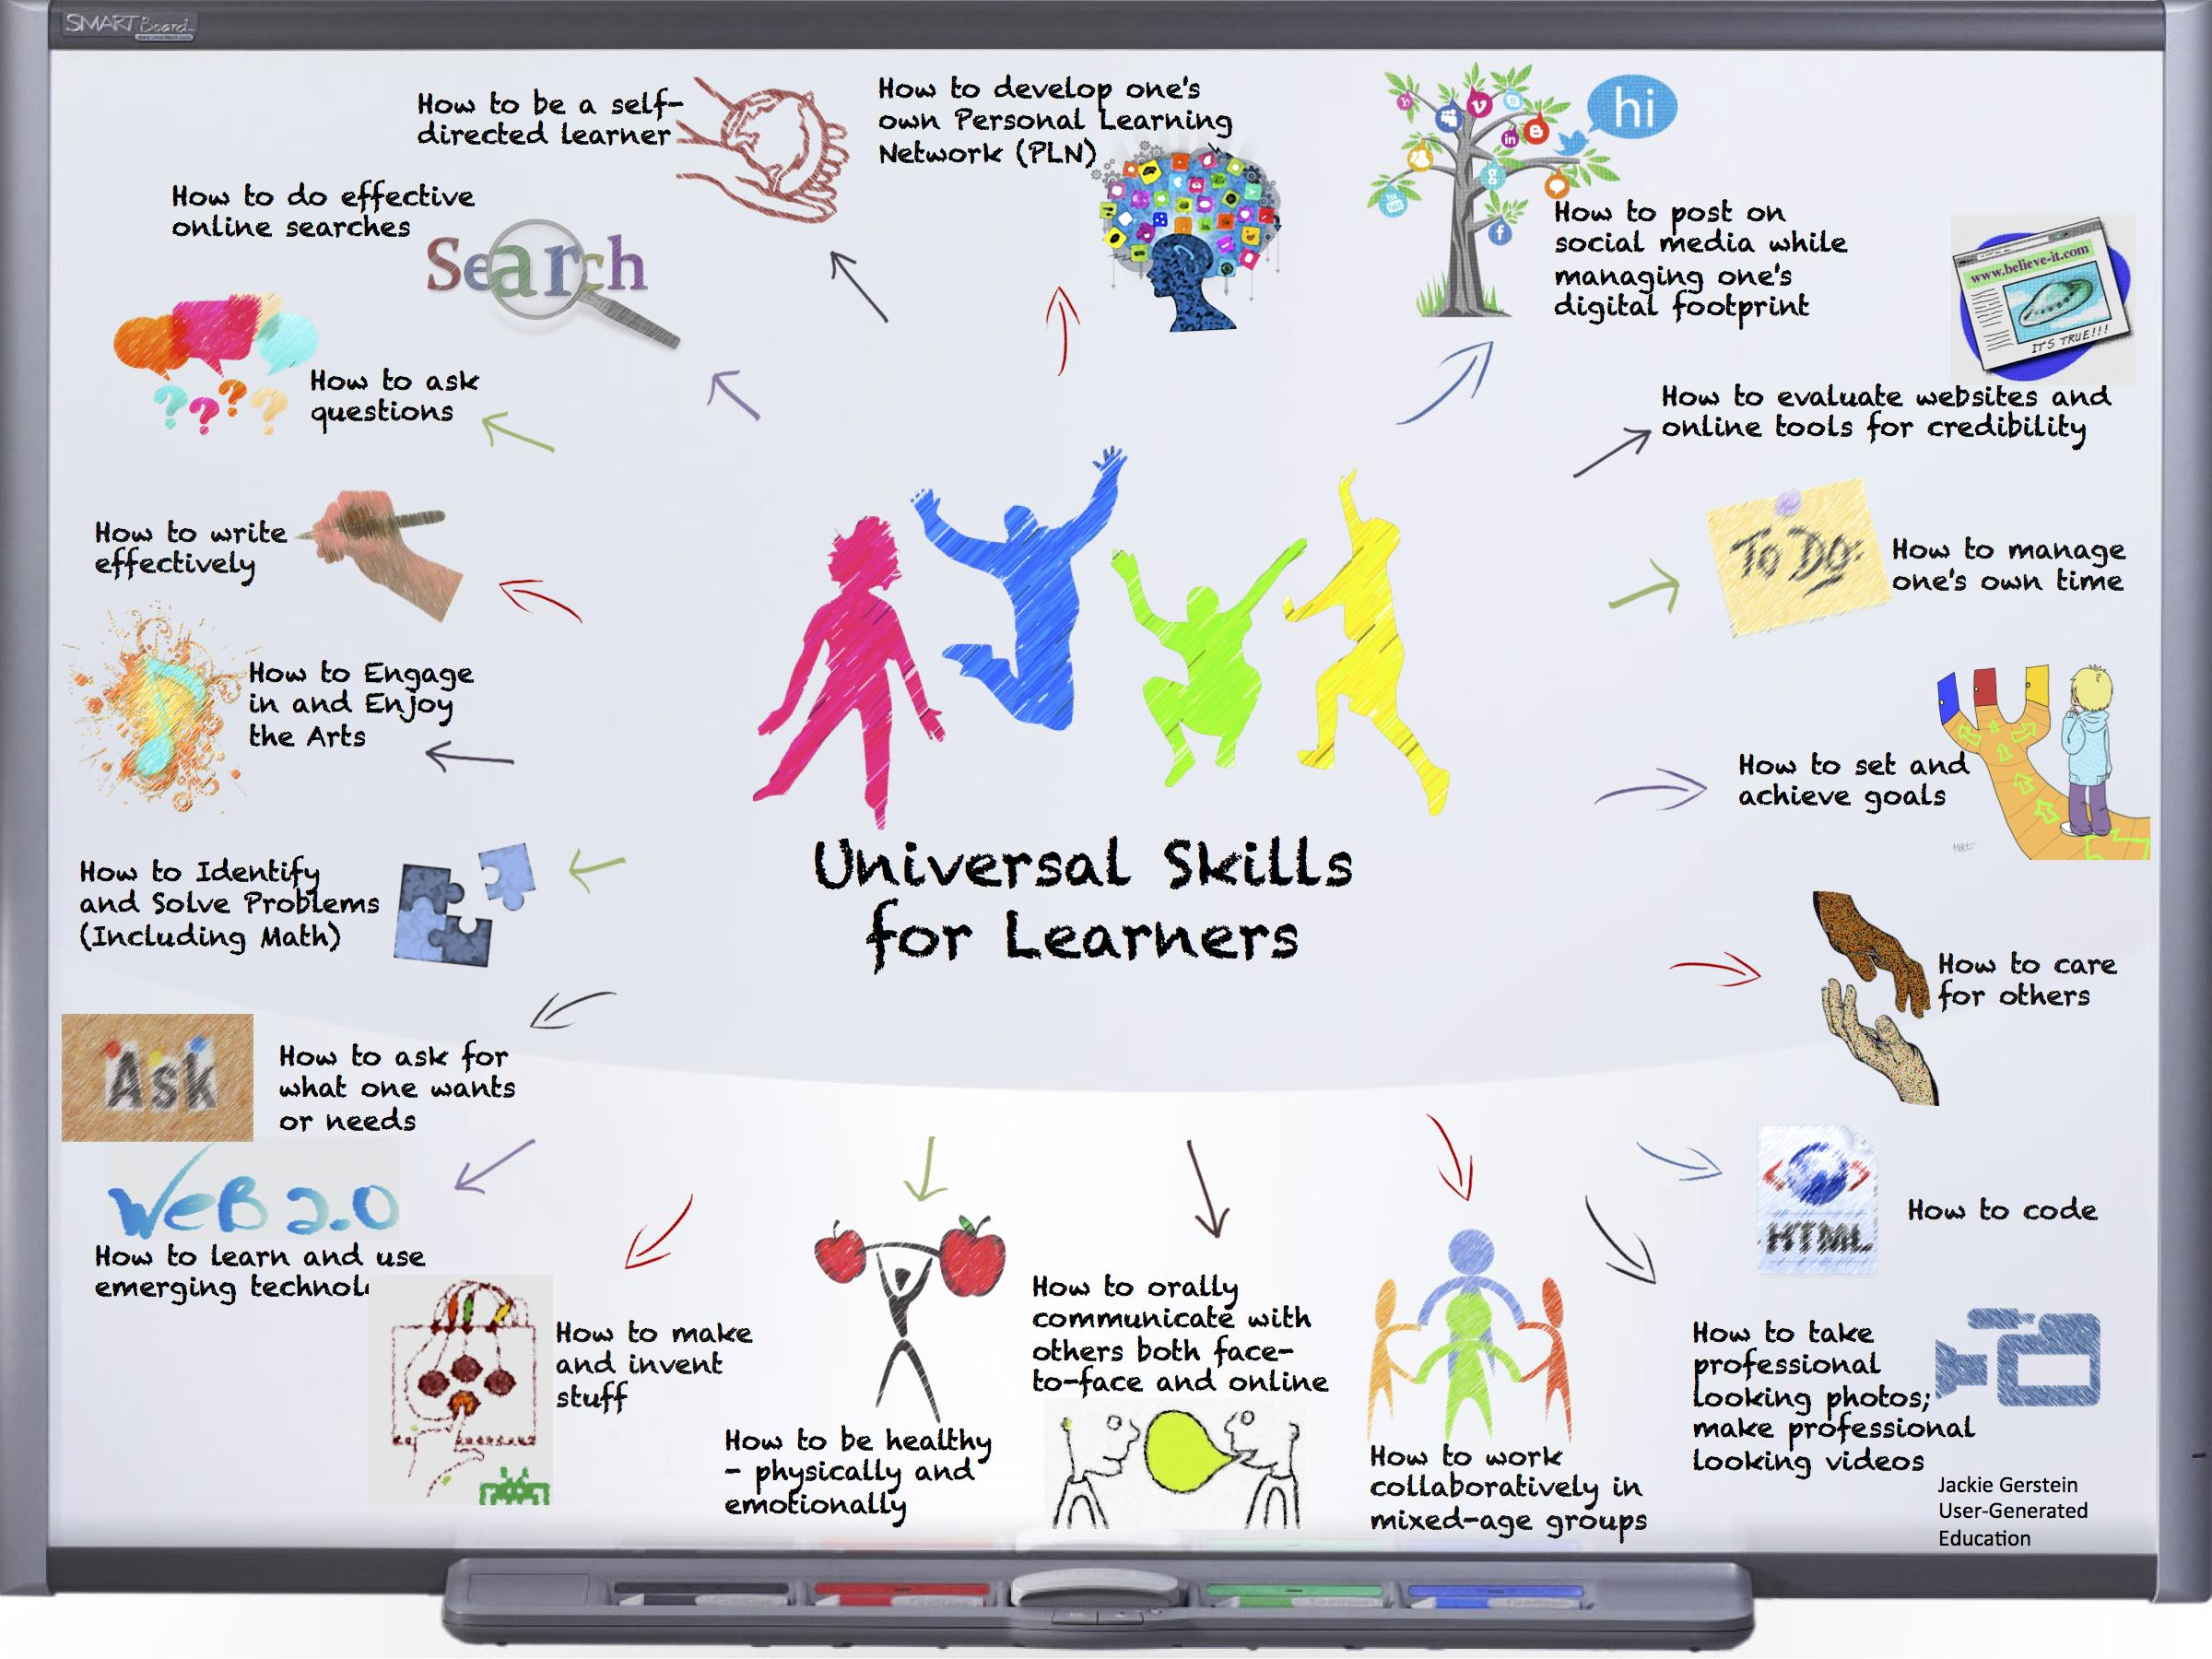

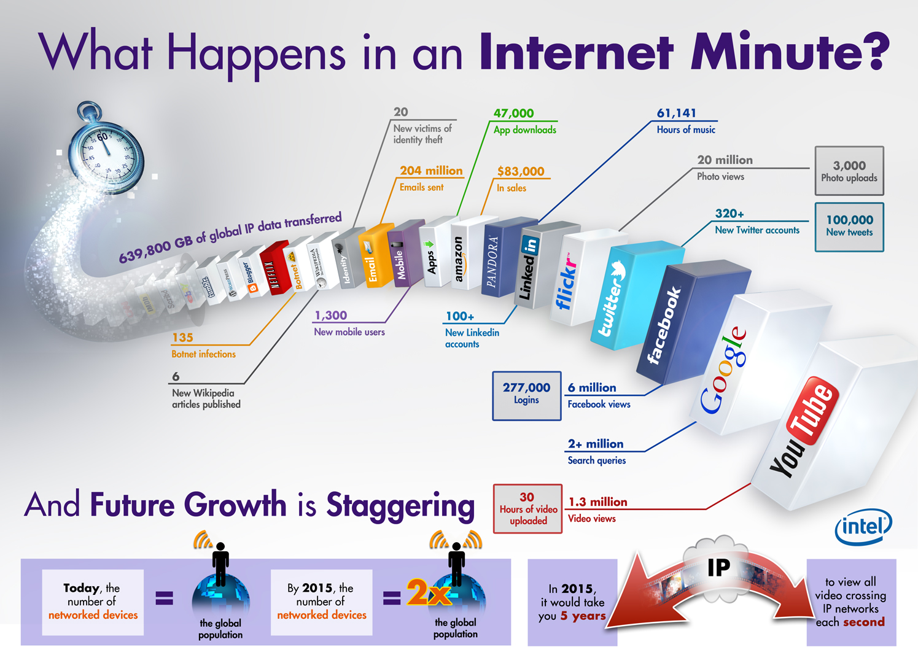

And here’s how some school are struggling with technology and change

* resistance - immune system issues -
* Lack of alignment - eg. multiple systems
  + Calamity when we use multiple platforms eg. google, school server, word, windows etc.
* Support removed just as progress begins
* Deluded beliefs
* TTWWADI (that’s the way we’ve always done it)
  + staff meeting that the only end point is we’re all older by 1 hour
* Low expectations due to outdated systems
  + eg. sending kids out of class to solve problems
  + wasting time adding pretty borders, fonts etc.
* No urgency - “keeping up”????
  + come and see us Term 3 … no too busy come term 4 … no got camp …
  + Well differentiated, well structured events spread out across the year.

***One reasons people resist change is because the focus on what they have to give up, instead of what they have to gain.***

We are living in exponential times - we need to keep up

Types of Ress

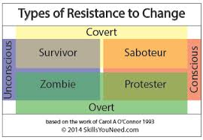

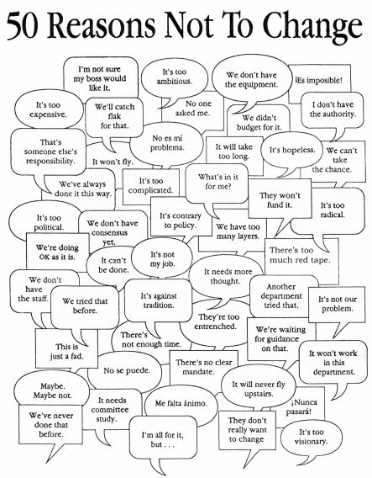

What you allow is what will continue!!



The 80-20 Rule - The pareto Principle

If you keep on doing what you’ve always done … you’ll keep on getting what you’ve always got.

One size fits …………… nobody!!!

Differentiation, scaffolding, feedback,

Technology will not replace teachers, but teachers who use technology (effectively) will replace those who do not.

Here’s how many schools are improving …

* structural shift lead from the top that includes awareness of how the world is shifting goo.gl/W8SiU3
* Technology used effectively and creatively by everyone
  + Major concerns around the addictive nature of using devices
  + needs to be structured, purposeful and limited
* Use resources wisely
* High expectations and adaptive systems
* Effective and ongoing PL
* Alignment

Schools have 3 forms of very valuable resource

Time

Money

good-will/motivation of teachers

And ICT can either grow these resources or it can burn them all, at a terrifying rate!

See - Managing Complex Change (Leroy Model)

Must convey ‘what’s in it for me?’ - Very important - don’t want to have a false start

Become a knowledge Catalyst

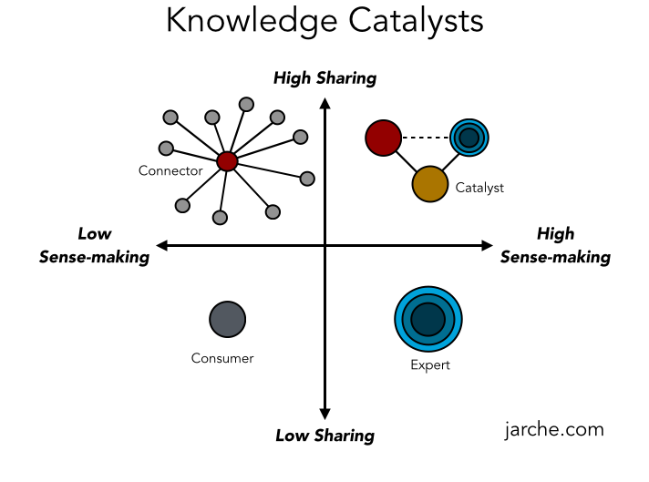

Change your mindset - say your words carefully.

**To be successful in 2015**

We need IQ

We need EQ

We need TQ (technologically competent)

We need BQ (bloody quick)

No matter what people tell you, words and ideas can change the world (Robin Williams)