Cheryl Doig - Leading in a Complex World

**Challenge Zone**

Certainty/Agreement - Status Quo

up to

Uncertainty/Disagreement - Chaos

Adaptive Leadership: mobilising people to tackle tough challenges and thrive

**The Cynefin Frameowrk**

**Leading Change**

|  |  |
| --- | --- |
| **Complex**   * Multiple connected but unpredictable interactions * Decisions are uncertain and only apparent in retrospect   Metaphor: eg bringing up kids | **Complicated**   * Multiple predictable cause and effect interactions * Decisions require expert knowledge   Metaphor/Example: an operation - surgeon has an expert body of knowledge to call upon.  eg: implementing a new reading programme |
| **Chaos**   * Multiple disconnected interactions * Decisions need to be made quickly | **Obvious**   * Simple cause and effect interactions * Decisions are obvious   Metaphor - recipe |

In the centre is **‘Disorder**;

Snowdon video re Cynefin Framework

* Three types of system - ordered, complex and chaos
* Different problems require different types of responses
* We have a natural tendency to categorise problems based on our own knowledge, skills and previous experiences.
* It is possible for a problem …. (did not finish)

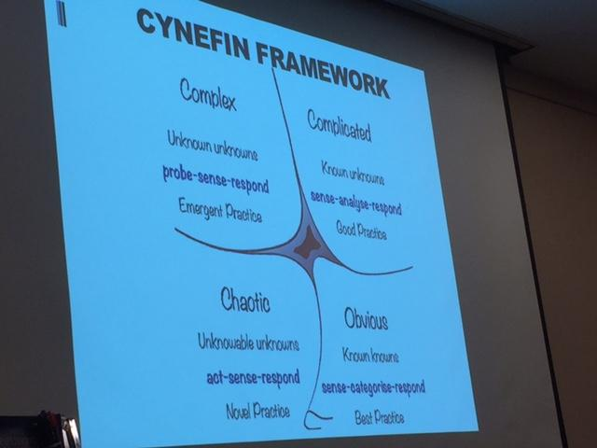

Cheryl has research available re MLE research re ‘does it work’

Dampening and amplifying

eg. create safe to fail experiments and no attempt to create fail safe design.

ideo - design thinking kit for educators.

**The Design Question**

***How might we*** … involve students in designing their own learning

***so that*** they start to make choices and problem solve

***because*** these are skills that they will need in order to thrive in the future

eg? Maybe

how might we … get teachers to see the benefit of upskilling/coaching

so that … they understand curriculum

because … we should never give up learning new things

Get people involved in the process ...co-create how we see it.

Write down everything you think is bad about ILE

Now flip it

Change begins the moment you ask questions …

eg: ‘how do we create conditions that allow students to be stunningly successful? (glass half full)

How can we get student up to par? (glass half empty)

Questions and change happen in the same moment.

Watercooler Meeting: Rapid Cycles of Learning Design Accountability

Everyone in the team answers 3 questions

What did you do in this cycle?

What will you do next?

Is anything in your way?

Campion keeps things on track and works to minimise obstacles. Team member make commitments in front of peers. Observers can observe!

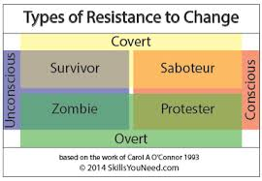

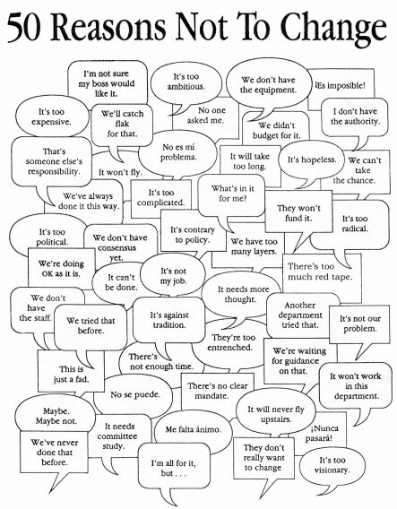

What you allow is what will continue!!



The 80-20 Rule - The pareto Principle

If you keep on doing what you’ve always done … you’ll keep on getting what you’ve always got.

One size fits …………… nobody!!!

Differentiation, scaffolding, feedback,

Technology will not replace teachers, but teachers who use technology (effectively) will replace those who do not.

Here’s how many schools are improving …

* structural shift lead from the top that includes awareness of how the world is shifting goo.gl/W8SiU3
* Technology used effectively and creatively by everyone
  + Major concerns around the addictive nature of using devices
  + needs to be structured, purposeful and limited
* Use resources wisely
* High expectations and adaptive systems
* Effective and ongoing PL
* Alignment

Schools have 3 forms of very valuable resource

Time

Money

good-will/motivation of teachers

And ICT can either grow these resources or it can burn them all, at a terrifying rate!

See - Managing Complex Change (Leroy Model)

Must convey ‘what’s in it for me?’ - Very important - don’t want to have a false start