**Anne Robertson -**

**Connected Learning Advisory**

**Aims**

Transform educational practice

provide advice and support

enable dura to plan, implement and extend

Creative Commons Licence - ensure school has one

Portfolios for Registered Teacher Criteria and Appraisal

Dr Helen Barrett

<http://electronicportfolios.org/>

portfolio guru

RTC = PTC (practicing teacher criteria)

parts of an elephant analogy to the portfolio

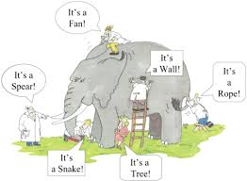

Showcase idea of portfolio - don’t forget the process, the mess, how they got to the end product.

**What**?

What did I do? - what needs to be put into portfolios - the things we have done.

Things we do with our students

Articles we read etc.

Everything we do should be at some stage, in some form should be included in our PTC portfolio.

**So What?**

How did I do it, what did I learn?

**Now what?**

What will I do next?

Reflect on why?

The overarching purpose of portfolios is to create a sense of personal ownership over one’s accomplishments, because ownership engenders feelings of pride, responsibility and dedication. (Quote from someone??)

Should be allowed to create a portfolio of your choice - not one size fits all.

**What to include in your portfolio**

1. Your teaching inquiry focus
2. The data/information you used
3. Evidence needs to be necessary and sufficient

Whatever platform we use … teachers should use personal email addresses as if they leave during the year it can be very difficult to ‘take’ your portfolio with you.

Your reflections

Different perspectives - student and parent voice

Stages of inquiry journey

Evidence of the measured outcome

Evaluation

What did we learn?

What new ideas did we get

What could I do better?

etc.

Rhizomatic Learning

Finally all 12 criteria are matched over 3 years.