**The Layout of the discussion will be;**

**Discussion around RTC** *1, 7, 8 and 12 (done in holidays)*

**“Perception check” re vision/LQs** *– (discussion only related to your thoughts)*

*1.  What is your understanding of what we are hoping to achieve and why?*

See learner qualities embedded naturally in learning

See elearning embedded naturally in learning

See Digital citizenship and PRIDE values embedded naturally in learning

By doing both these things naturally (in meaningful and engaging contexts) students will become empowered, confident and connected 21st century citizens.

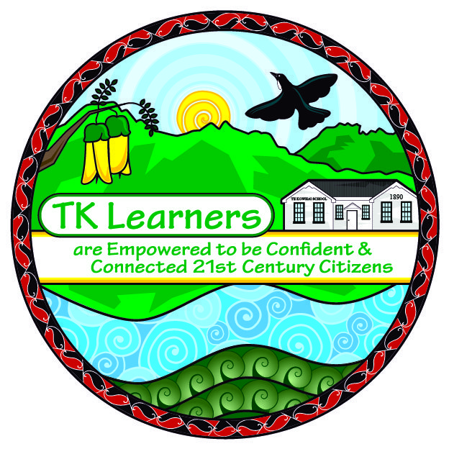

*2.  What excites you about the current direction of the school?*

I am excited about the notion of Personalising Learning more for students.

I would like to know more about inquiry learning as I believe this is a great way for students to ‘own’ their learning – and a vehicle leading towards more learner centred learning opportunities.

I have enjoyed reading about the differences between differentiated, personalised and individualised learning programmes.

I like the TAI process and enjoy learning more about teaching and learning pedagogy.

*3.  What challenges you about this direction and some of the implications for your teaching?*

Making it work and making in manageable! I struggle now with having a work/life balance and fear the new direction will make this worse?

I would like to work, at some stage, with older children so as to have more opportunities to teach depth of understanding to students.

I would like to see elearning more naturally integrated into my programme – this has been difficult this year with the development of our MLE – a lot of my time has gone into working out workable systems for the MLE to run smoothly.

*4. What did your change model bring up as a next step?*

* Keep personalising learning in writing – children becoming more aware of why, how and what they are learning.
* Bring a more personalised approach to maths – nicki and I have been working towards doing this – Nicki created the ‘snatch it’ groups to highlight focus kids needs in maths knowledge. We have started putting goals up on the walls more visibly – although it is early days.
* I got rid of my published wiritng wall in favour of a writing in progress wall – this still needs tweaking and need to have evidence of student /peer feedback and student voice etc.

**“Where to next?”** *- (This will be recorded as we go on your TAI page in MyPortfolio)*

*5.  Is your current TAI still relevant? why/why not?*

Kind of – working with a new bunch of kids now – must get some of their student voice recorded. Also need to continue to embed the LQs into our day more as this has dropped off a bit.

*6. So, what is your next TAI step?*

Record some Student voice for a new set of students – perhaps get Nicki and Mandi to record the kids that I started with?

I would like to focus on Kobi, Sharlise, Hayley, Te Manahera, and Rhys?

*7. What can we help you with?*

I would like to explore inquiry learning perhaps? This would help when teaching electives, but would also like to explore how I could integrate inquiry within literacy and numeracy.

Time, Time and more Time to record student voice, update MyPortfolio, read and resear4ch

*8. How could student voice gathered before and after this next phase assist you in gathering evidence of whether your actions have an impact?*

I think the answer the original students now give will be remarkably different from those at the beginning of the year. Alysha, Chase, Heleina and Bailey should all be able to articulate the Learner Qualities to some extent – an improvement on them not knowing any at the beginning of the year. They should (hopefully) know why they need to learn to write and read, and how they know they are getting better (pink and green goals), they should know what their next steps are (especially so if they have access to their writing books).