**Cheryl Doig**

Leading in the Future: Critical Capabilities for Success

A lot of change happening in the world and in education.

Times of rapid change

Biometrics is all around us. WYOD (wear your own device)

Horizon Report - created by educators around the world - looking at technology that will affect education.

STEM - science, technology, engineering, maths?

STEAM - science tech, engineering, arts, maths

**New types of jobs in 2030 - by 2030 more than 2 billion jobs will disappear**

* Telesurgeon
* Coder
* Limb Printer
* Commercial Drone
* Developer
* Freelancer

Exponential Change

The half life of a learned skill - was 30 years … now 5 years time.

SANE Leadership

**S**elf

**A**daptive

**N**etworked

**E**thical

**Self** -

* Mindfulness
* Awareness of self and influence on others
* Presence
* Personal time flow
* Technology as a part not as a whole - (technology is getting harder to turn off)
* Ubiquity -

Digital Detox

We need to balance our presence on devices

Technology becomes an immersed life!!! -

Make time for family - date night Wednesday - Build relationships. Self regulated behaviour - personal time

Trello - self regulations support -

30/30 - Chunks your work in time blocks

Notion of ‘Agency’

* Waiting to be … engaged, professionally developed, told what to do

Not our role as leaders to be responsible for professional development. ‘What did you do about your own professional development?”

**Adaptive**

Flexible responses as you interact with the changing environment

It requires an inquiring … (did not get to copy down)

Confirmation Bias - Interpreting new information so that i becomes compatible with your existing theories, beliefs and convictions, (A mirror for our existing values)

Confirmation Message

**The ordered World**

“Schools need to ensure their teaching is based on genuine evidence based practice, reflects their community values and is not just the latest education philosophical trend”

**The Complex World**

“Leaders will have to be multilingual, flexible, internationally mobile and adaptable. But, most crucial of all, they must be highly collaborative and have strong conceptual and strategic thinking skills”

I need to sometimes be happy in the grey space - be adaptive

What the human being is best at doing is interpreting all new information so that their prior conclusions remain intact.

**Dealing with Confirmation Bias**

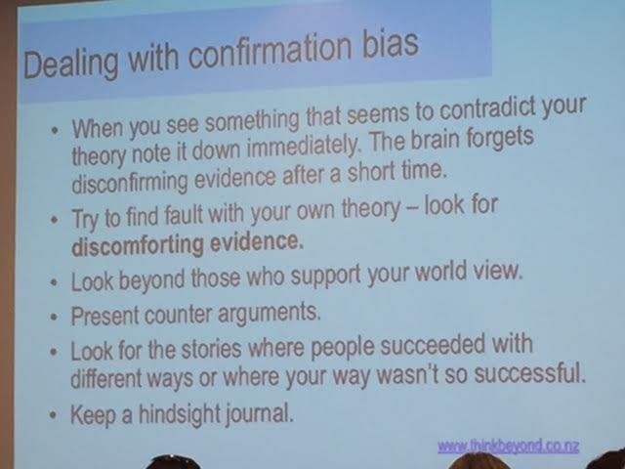

**School as a #learningecosystem**

* Fit for purpose
* Adaptive
* Agile
* Complex
* Contextual

Think beyond what my immediate team is doing … (We already do that in our learning area)

**Networked Leadership**

Weak ties matter more than strong ties

Make links with people continuously

The Participation Culture

* The rise of the culture of participation + tools + power of network will = ….

Teaching with a capital T

Agents who weave learning as ...

* facilitators
* activists
* curators
* knowledge experts
* bridge builders (make the links to other curriculum areas)
* boundary spanners
* role models
* innovators
* inquirers

Be a **provocateur**

Leaderships is **being** not doing

**Ethical**

Watch the footprint they have left

Digital Citizenship knowledge

There will always be people who will find us online - watch what you say and do at all times.

* Contribution
* Coherence - what you say is what you do!!!
* Consistency

Attracting and maintaining talent through personal and organisational behaviour

**Final Words ...**

Use the **FEW** strategy - ask new teachers/visitors to take a ‘fresh eyes’ walk. Tell me what you see. Give me feedback before you get diluted by the system

When it gets tough - enabling constraints

The boxes we push out or in against - the frames that force us to think, to distil, to arrive at the essence of something.

If one thing doesn’t work - pus in another corner, keep working, to ge tto the essence of the change, treat the boundaries as your friend. Think adaptively and start making the changes you can.