**Jeremy Kedian**

Building Professional Learning through Dialogue

Have you ever stopped to think about the effort we put into professional learning in schools - the amount of money.

Mediated through language

**The** **Context**

* No explicit leadership qualification required for Principalship in NZ
* No requirement for on-going professional learning
* Limited professional learning opportunities
* Dominance of neo-liberal paradigm - if you’re delivering the goods that’s all that counts. - Hopeless to think this is sufficient
* The desire of many Principals to grow

**One-size fits all**

Prevalence of ‘stand and deliver’ approaches.

(workshop, seminar, lecture)

The high workload of principals is compounded by boring, externalized presentations that are important to the presenter (and perhaps no one else!)

**So what are the assumptions?**

* That attendance equals learning
* That the topic is relevant to all or most participants
* One presentation or teaching style suits the learning needs of a large groups of adults
* Differences in context - personal and professional - make no difference
* Plus all of the assumptions we make about school based learning

**An international Dialogic Institute**

* 4 days of dialogue
* assigned to random groups
* dialogue process described
* focus area are described by participants
* facilitators assist with the process and sharing of group information, reassurance, health checks

**What is dialogue?**

dia = through

logos = word, meaning, relationship and the ‘space between us’. … an ordering principle of the universe

Dialogue is the intentional and sustained inquiry into the assumptions, certainties and processes that structure common experience and inform collective action.

There are certain things that we know are true -school’s in their current form are no longer fit for purpose - intermediate school’s are a waste of time and money. (Jeremy’s opinion)

Assumptions are just that … assumptions

Accumulated wisdom from just dialogue

**Dialogue moves**

**from to**

knowledge insight

decisions choices

competence vulnerabiity

knowing wondering

answers questions

expert beginner’s mind

precedent living now

fragmentation wholeness

He just doesn’t know if this ILE will work. Where’s the evidence it works?

Early child educators got it right - holistic approach

**Dialogic Process**

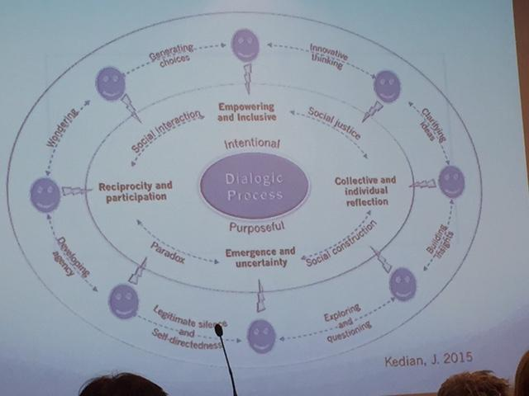

Greatest enemy of introverts is brainstorming

Inner dialogue okay

Assumed competence in staff meetings

Dialogue ground rules

**Key Professional learnings …**

* parallel of individual growth and social constructionism
* challenges to personal world view
* The value of trust and relationships - even in the short term
* Ongoing effects of the dialogue and the dialogic experience
* Impact on confidence and self-belief
* Connectedness (with their original group) and trust
* Power of dialogue to seed ideas
* Coaching and mentoring application
* Openness to new ideas in the workplace

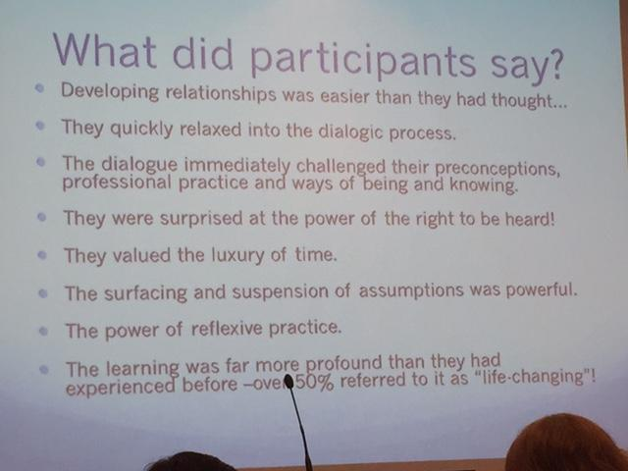

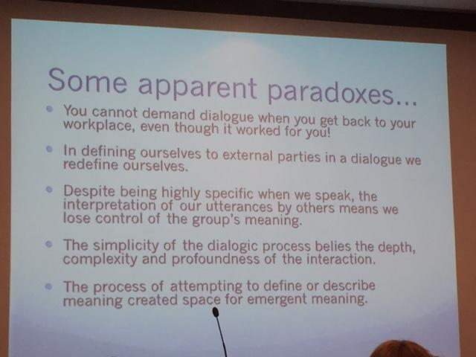

The value of complete presence!

The place, value and power of silence.

Managing vs. Leading

*The carpark assassination squad!*