**Dan - Hobsonville Point Principal**

Would you or your parent community still attend a dentist who was practicing with old school methods and technology?

No generation in history has ever been so thoroughly prepared for the industrial Age as the current generation? David Walrick

**What should we focus on?**

Personalised

Engaging

Real life

Collaborative

Relevant

Responsive

Messy

OUr students will need to learn to

* Deal with massive amounts of data
* Have global communication skills
* Self direct/self motivate/self start/self regulate
* Organise/collaborate/plan/reflect/assess (self, peer, expert)
* Have multi-level relationships
* Sustain their learning
* Learn through real life projects/inquiries (OECD conference in Finland “Grasping the Future:” identified this as crucial for the future of the young).

Our Students will need to develop

* Self-motivation
* Self discipline
* perseverance/commitment
* balance/sustainable
* Coachable
* Self managing
* courage/tenacity/dive …

**What do we value about learning?**

It is firstly important that everyone is on the same plage in what they ‘value and believe’

**Hobsonville Point Values:**

Relationships

Innovative practice

Authentic learning

Collaboration

Personalising Learning

Use circles to frame up thinking - why (relationships - vision and beliefs), how (principles), what (practices)

Dreyfus Model - the notion of your journey as a learner.

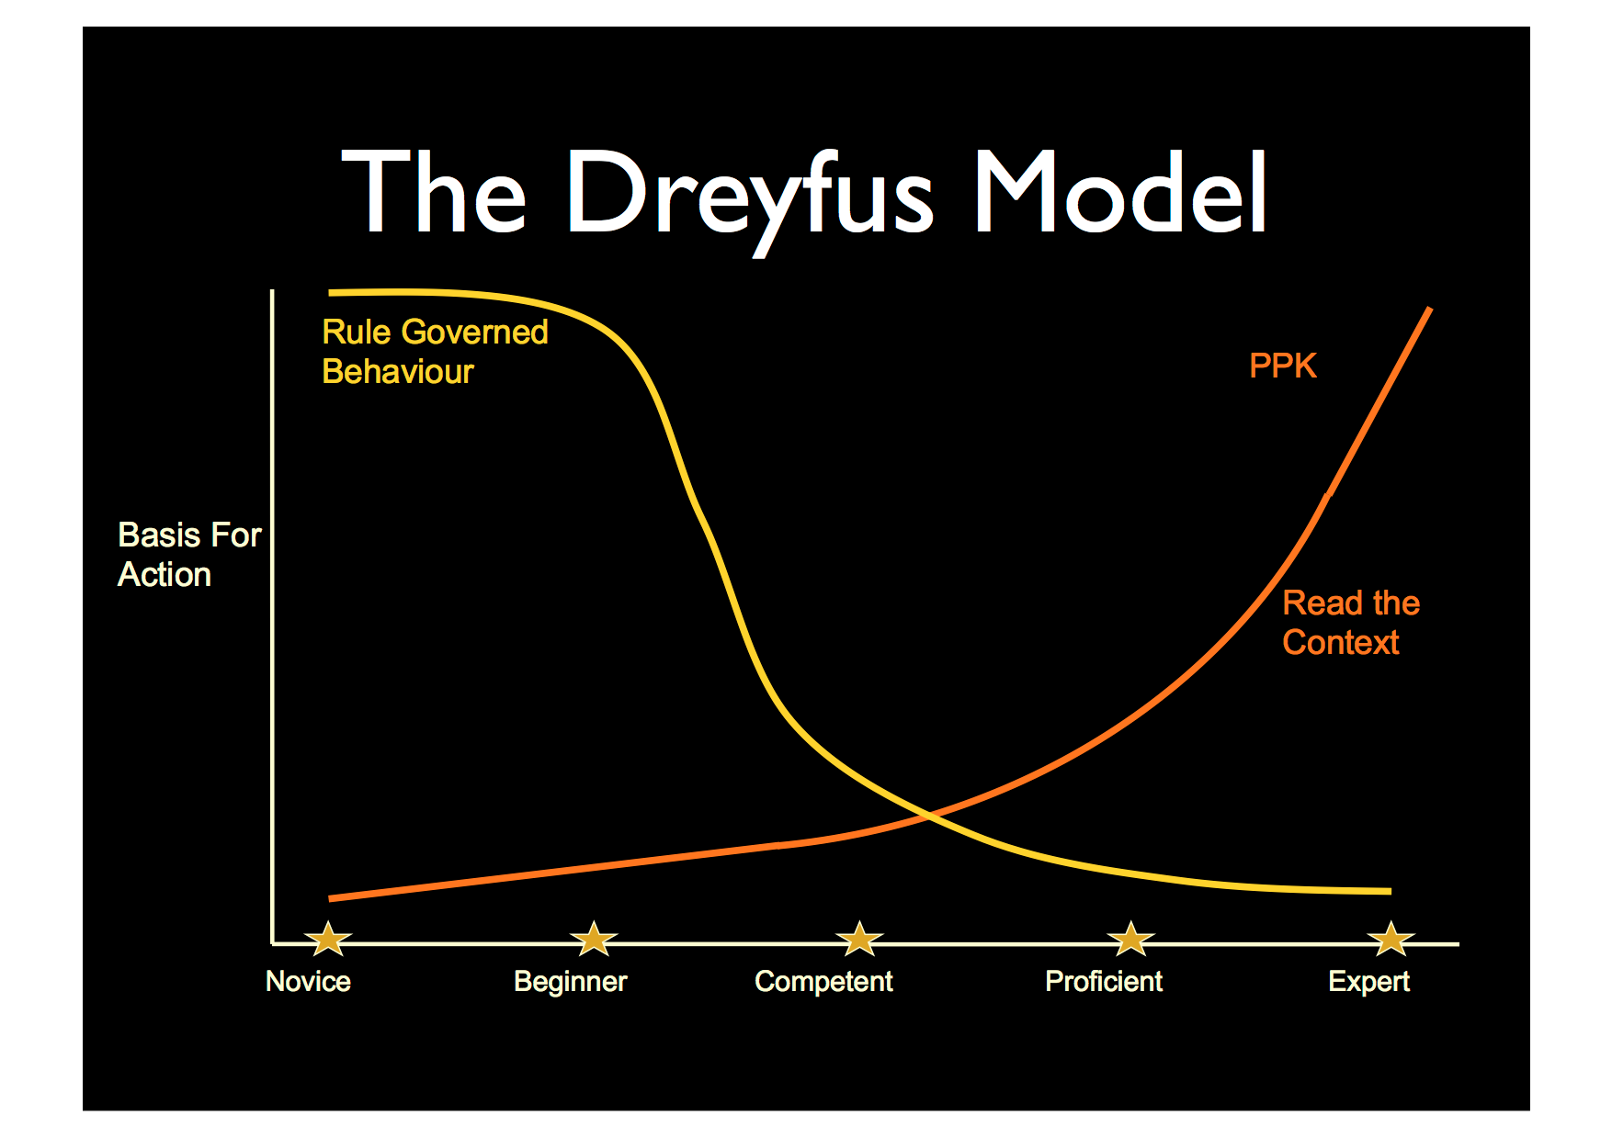

Learning - everytime you learn something you need new scaffolds.

**How do you share learning?**

Share in a range of ways for parents to access it. Twitter, FB, walls, website, newsletters, School App).

Google Plus Community for staff - put educational readings up - reflect, comment on etc.

Share lots of stuff with our parents.

Planning online for parents or whoever to see - more like a programme overview not indepth planning.

Is ‘learning’ visible on the walls? Or is it just ‘art’?

Visual representations of where kids are going on their learning journey.

Learning on the walls!!!

**Parent/staff Andragogy**

* Personalised
* Relevant
* Reflective
* Responsive
* Real