**Sue Kohn-Taylor - Personal Development Coach**

Elevating Personal and Business Performance

Improvement more about the people than the establishment?

Often skills based training - not the development of the person.

* Being the Difference
  + Taking responsibility
  + Understanding self
  + Power to influence and coach others
  + Step up - take responsibility
  + Lead by example
* The moment you take Responsibility for your life is the moment you can change your life.
* Do I let life lead me … or do I lead my life?
* But the moment you blame others for your lack, in any capacity, you put yourself in a tough spot.
* Only 10% of the population ever step up and lead their life.

What will you learn today?

* Understanding of self awareness and how it assists yo
* Who am I?
* What is it that I need to change?

*and that your life is all about the choices YOU make!*

**Self Awareness**

Having a clear understanding f yourself including strengths, weaknesses, thoughts, beliefs, and emotions.

Understanding yourself in a way that allows you to understand who you really are and why you do things in the way you do.

Self awareness is the foundation of personal development - growth and success

NO two brains are alike!!

We all operate in an emotional state: thought, emotion, behaviour

Emotional Scale

Away/Threat Toward/Reward

Default Behaviours Your Zone

Your zone is the gold place to be.

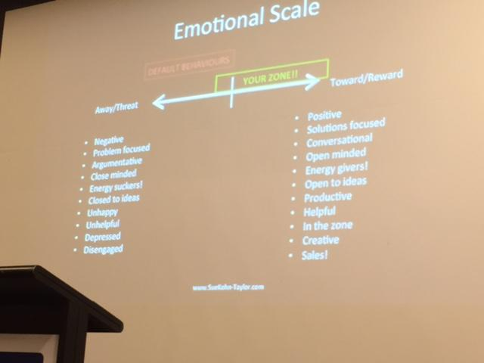

**Who are YOU?**

How well do you know yourself?

* Public You
* Private You
* Unknown You

**The Johari Window**

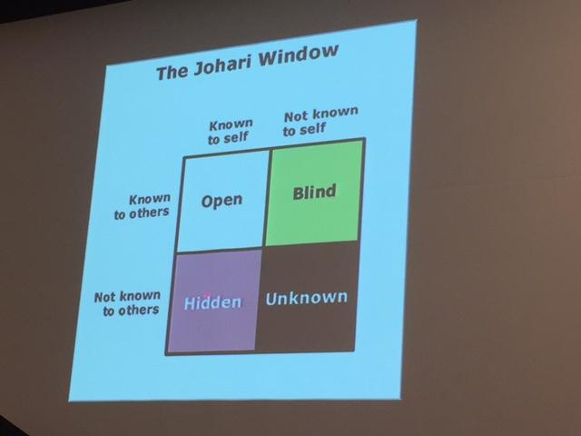

**The Wheel of Life**

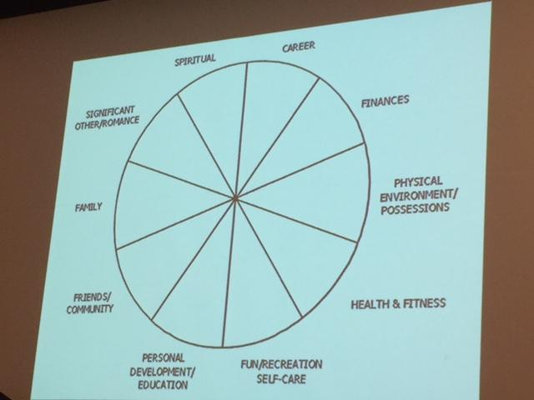

**What holds most people back in life?**

1. Lack of planning - goals vs wishes
2. Who am I? What do I want?
3. Self Limiting beliefs and default behaviours
4. Attitude/Mindset
5. Fear!

* Not truly understanding who you are?
* Listen to yourself
* Excuses for not doing stuff - fear factor
* When you stay in your comfort zone - you’re growing - can become dangerous and boring
* Attitude and mindset - peel back the onion - strip the layers back - when I put up excuses have a look and ask why and what that’s all about.
* Ask myself - “what holds you back, what am I afraid of?”

**Be the most powerful version of yourself**

* Take action now - start!
* You are your best investment
* Life is short - make it the best
* Personal Development for life
* Be curious / be reflective / journaling
* Don’t get caught up in other beliefs, judgement and stories
* You are living your life not the life of others - let them get on with theirs
* Drop expectations!
* Minimise the judgment!
* Work on yourself everyday - even if it is small
* Be self aware and work towards being in your zone - its the best place to be!

It only takes one person to change your life - that’s YOU! You are your best investment!

Be energy givers not energy suckers!!!