**Sue Kohn-Taylor - Personal Development Coach**

Next meeting - Resilience and Stress,

**21st June 2016**

Human Needs Test

Who are You?

* Public You
* Private You
* Unknown You

Summary of You (this is a summary of Sue)

* Strong minded, independent, love giving and receiving affection, very loyal.
* Motivated by inspiring others, personal development is a passions, love learning, intelligent, quick minded, energetic.
* Love yoga, need to be more disciplined in exercise, love people, can scatter my energy across too many activities.

**Human Needs**

1. Uncertainty/Variety
2. Certainty
3. Significance
4. Connection/Love
5. Contribution
6. Growth/Learning

We all have a drive for fulfillment and experience a life of meaning …

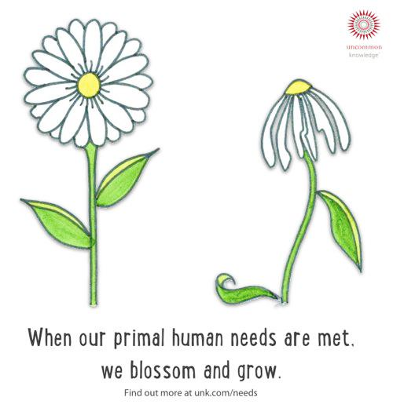

The **three human needs most needed to gain fulfillment**

* Love and connection
* Growth
* Contribution (giving to others)

We need variety of DRIVERS to keep us growing.

**Certainty**

* Knowing makes us feel safe
* In our comfort zone
* Assurance you can avoid pain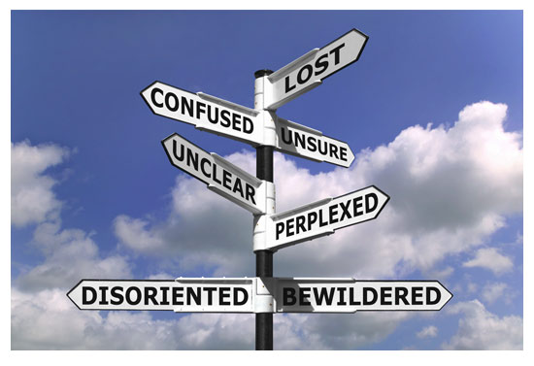

**Uncertainty/Variety**

* Need for the unknown
* Change
* Stimulus
* Makes us feel alive and engaged

**Significance**

* Feeling unique
* Important, special
* Needed
* Life has meaning and importance

**Love/Connection**

* A strong feeling of closeness
* Union with something or someone

**Growth**\*

* An expansion of capacity, capability or understanding
* New learnings
* Expansion of self - self awareness

**Contribution**\*

* A sense of service
* Helping, giving to and supporting others

The moment you take responsibility for everything in your life is the moment you can change anything in your life. (Hal Elrod (YoPalHal.com)

Personal Development is a life-long process

You are your best investment!!

It only takes one person to change your life - that’s you!

**9th June 2016**

You’re powerful beyond measure …

To be in my power zone

* Exercise
* Sleep

What are my Triggers?

**Fear** is an idea-crippling, experience-crushing, success-stalling inhibitor inflicted only by yourself.

Fear is everybody’s trigger - and puts them into a negative state.

FEAR

* False evidence appearing real
* Fear is not always real
* It robs us of happiness
* We are not present
* It causes us to settle for less than what we are capable of
* It is the root cause of negative emotions

Fear is often not real/reality. Fear of the unknown - takes us out of our comfort zone.

Where your focus goes your energy flows.

Focus on where you want to go, not on what you fear!

What are we afraid of?

* Fear of failure
* Fear of rejection
* Fear of the unknown
* Fear of isolation
* Fear of success
* Fear of the loss of self
* Fear of love

Reality of fear:

You’re not scared of the dark.

You’re scared of what’s in it.

YOu’re not afraid of heights.

You’re afraid of falling.

You’re not afraid of the people around you

You’re just afraid of rejection.

You’re not afraid to love

You’re just afraid of not being loved back

You’re not afraid to let go.

You’re just afraid to accept the reality that it’s gone.

You’re not afraid to try again.

You’re just afraid of getting hurt for the same reason.

Take the power away from FEAR

Fear only becomes powerful when you give it your power!!!!

Start understanding what the FEAR really is

|  |  |
| --- | --- |
| **Things I am fearful of ...** | **The reality ...** |
| Bugs | They are tiny and cannot hurt me.  They are creepy. |
| Death of self, children, spouse | Death happens, it would hurt emotionally, but life will go on. Other people will step up and support self/spouse/children. |
| Mice | They are small and cannot hurt me. They are fast and sneaky. |
| Cancer - getting it myself or having an immediate family member battle it | Live a healthy life - eat well, exercise and enjoy every day. Fill my dash with ACR (action, comedy and romance). What will be ... will be. |
| Applying for other jobs and being unsuccessful. | Don’t know till you try - I have a good set of skills/attributes. |

**Exercise/Tools to minimise fears:**

* Write it down - Confront it - Get more information.
* Figure out what you’re afraid of. Peel back the onion!
* Check your self talk.
* Share your fears with others.
* Rate each fear on a scale of 1 to 10 - how likely is it to happen.

**A Plan for Change/Action**

* Start by setting small goals.
* Learn how to explore and evaluate all possible outcomes rationally and develop contingency plans.
* Practice thinking positively.
* By examining, planning, being in control and being more positive you’ll begin to overcome your fear and become more confident.

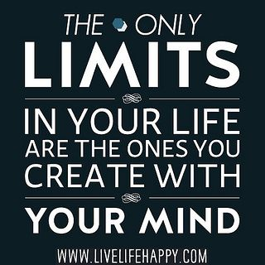

Self limiting beliefs are the ones that really stop us … I can’t do this because …

***Two people who have overcome difficulties ...***

* ***Cam Calkoen***
* ***Nick Vujicic***

**What is a Belief?**

* It’s a feeling of certainty about what something means or the way things should be done - a 1 dimensional view based on your experiences and learnings.
* People, TV, Radio, Books, Magazines etc.
* Often our beliefs are mis-interpretations.

**The challenge:**

That most of our beliefs are generalisations about our past based on interpretations of painful and pleasurable experiences.

They become embedded in our subconscious and often go unchallenged over time.

**Beliefs**

Beliefs are very important in life so long as they are not unhealthy or negative.

**Some Common limiting beliefs**

I’m not important

Making money is a struggle

I’m not good enough

I’m not smart enough

I don’t deserve it

I am too you, people won’t take me seriously

I’m too old, it’s too late to start …

I am a hard worker. I work hard for money.

Just my luck, problems always follow me.

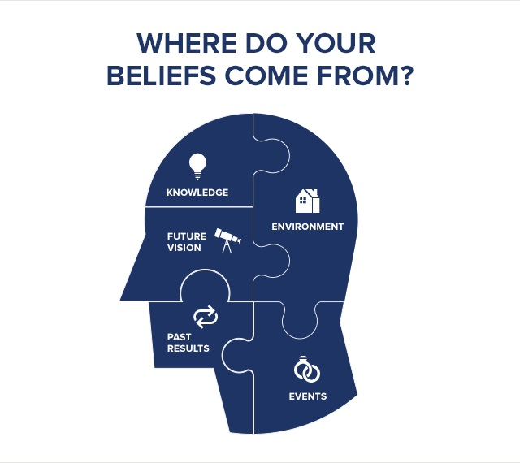

**Exercise**: Think about ...

How are self-limiting beliefs blocking your ability to live your best life?

Where do they come from?

What’s your most debilitating self-limiting belief?

How do you overcome it?

**Action to Take**

Understand and know that you can change the belief

Be aware - start observing your self limiting beliefs, write them down

Start challenging your self limiting beliefs

Peel back the onion!

Acknowledge the past is not the future

Change those self limiting beliefs to beliefs … (didn’t get it all down)

**24th May 2016**

How do I become the most powerful version of myself?

What will I learn?

* Understanding of emotions and their cause and affect
* Awareness of your default behaviours and triggers
* Awareness of YOUR POWER ZONE

Use book as personal book about ME

**Self Awareness**

* Having a clear understanding of yourself including strengths, weaknesses, thoughts, beliefs and emotions.
* Self awareness is about understanding yourself in a way that allows you to understand who you really are and why you do things in the way you do.
  + When you get challenged, emotional, hard done by by a colleague etc. - that’s the time to stop and say ‘what’s going on?’
* Self awareness is the foundation of personal growth and success.

Don’t every try to be the perfect person. Life is life and it will continually throw challenges at you.

What are my strengths, weaknesses, why do I think the way I do, why do I believe what I do?

Learn to understand my emotions.

Think about the great things and the challenging things that happen each day.

**Emotional Scale**

**Default Behaviours**

**Power Zone!**

Away/Threat _________________________________________Toward/Reward

**Triggers**

Negative Positive

Problem focussed Solutions focused

Argumentative Conversational

Close minded Open minded

Energy suckers! Energy givers!

Closed to ideas Open to ideas

Unhappy Productive

Unhelpful Helpful

Depressed In the Zone

Disengaged Creative

Sale Drive!

**Be responsible for the energy you bring into a room.**

Don’t be an energy sucker - people notice it, respond to it, remember it.

**The Cycle - understand yours**

Situation

Perceptions - Thought

Defaults - positive or negative Triggers - positive or negative

How do we keep our thoughts,

Emotions and behaviours in

‘The Zone?’

Behaviour Emotion

**Triggers**

* Emotional response to a situation, a person, words, feeling, that are said and so on.
* Activated through 5 senses: sight, sound, smell, touch, taste
* Usually a reminder of something painful from the past that then causes an emotional reaction and often a response behaviour (default behaviour)
* Challenging to identify our triggers

Common trigger - I will never be good enough

Write incidents in your book - in triggers write a brief statement eg. I am not good enough. I don’t like being challenged etc. Triggers that cause emotions. What has caused the emotion and why?

**Default Behaviours**

* An habitual way of behaving that helps deflect or defend feelings of pain from the past.
* Gen angry, become a people pleaser, be the super funny person, the YES person, shut-down and withdraw, turn to addictions, cut people down, become a victim, become critical, go shopping, eat, work longer hours …

What happens when I feel an emotion? What do I do?

**Understand Your Zone**

* Performing at a peak
* Feeling in the toward/reward state
* How long can you stay in your zone?

**What do I need?**

* Regular exercise
* Good food
* Passion
* Purpose
* Environment
* Systems
* Positive mindset
* Good attitude
* Breathing
* Hydration
* Sleep
* Happy partner/husband/boyfriend
* Happy children
* Support
* Stimulation - friends, colleagues, books, TEDX, personal development
* Love
* Security

**Bringing it Together**

* Awareness of who you are - your strengths, your weak points
* Awareness of your emotional triggers
* Awareness of your default behaviours
* **Awareness of your self limiting beliefs**
  + **(next session - challenging what your beliefs are)**
* Awareness of how to be in YOUR ZONE

Fear, Values, Self limiting beliefs, (9th June)