9.5.16

Colleen Wills, and Chris Jeffs

**Literacy and Middle Leader Workshop Series - Workshop 2**

Must BUY ...

**READ, WRITE, LEAD by Reggie Routman**

**Learning in the Fast Lane, by Suzy Rollins**

Big Takeaway - STEPS literacy resources etc. are a list of strategies, not deep thinking about pedagogy.

Use a range of evidence to inquire into their practice, what needs to change?

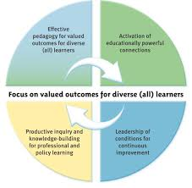

9-10.30 - Identify high impact pedagogies that can accelerate student achievement.

11-12.30 - How PLG groups can develop powerful learning partnerships between teachers and literacy leaders.

11-12.30 - How TAI can be strengthened and deepened with the development of PLG groups.

**What is Acceleration?**

Noticeably faster upward movement than might otherwise have been expected by the trend of their own past learning.

**Explicit Targeted Teaching** (Michael Absolum - Clarity in the Classroom, 2006)

Look into **‘Learning Hexagons’** as a tool for progressions. Highlight a side of the hexagon each time you notice the learning in a student’s piece of writing.

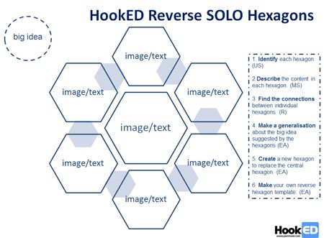

High Impact Literacy Pedagogy - Video Clip 1 <https://www.youtube.com/watch?v=mfqFoDSzgh8>

Record DATS etc. with team. Focussed lesson, specific purpose - similes

Delve into teachers attitudes, behaviours, about what they believe about teaching writing - [theory of action example - Year 1-3](https://docs.google.com/document/d/1cfsy5QONKJZyGeX80VH14P6D6XC73WVS0UMDHGrlKrk/edit)

Be culturally responsive - context that engage and reflect the students in my class and respond to their needs, interests and aspirations.

**Clearly defined learning focus or target for learning!! BE VERY SPECIFIC - chunks of learning**.

Cath Murdoch talks about linking new learning to prior knowledge - why are we doing this? Synthesising.

Unpack topic specific vocabulary before children write.

Multiple oral language opportunities to share ideas, beliefs and opinions.

Oral opportunities to label and make sense of diagrams and picture plans - in Year 1 and 2. Use key word charts/diagrams/ concept maps etc.

Co-constructing vocab walls and writing resources. Make charts of topic words, etc.

What **scaffolds** are we using to set students up for success **before** they write???

Using writing scaffolds - writing frames, templates etc. to provide models to students. [Scaffolds](https://drive.google.com/drive/u/1/folders/0B9BgQCWHsiO_aWRKMXRmajZvajQ)

Notice, identify, annotate and highlight - use **exemplars** to model the writing. Re-introduce the use of exemplars to provide model/motivation/expectations etc.

Visual success criteria - self checkers!

When giving examples of writing (exemplars, word lists, word work etc.) to students glue everything into their writing book (or special book for all these bits). Colleen thinks a separate book would be a good idea but I think … Maybe easier to use the writing book as opposed to another separate book?

**Vocabulary Development** - TIP charts - Suzy Rollins - buy book online - Learning in the fast lane

Three columns to unpack vocab word wall - Term, Information (definition), Picture (TIP)

Use a variety of planning tools - use online tools to find. Eg. Story maps etc.

Modelling what success looks like is really important at any age. Chunking lessons into achievable parts - **going slower to go faster.**

Deconstructing text - noticing language features and structure - pull writing apart, okay to borrow from other writers

Co-constructing success criteria - “if you’re successful today … what will your writing have in it today?” Allow time for self-checking.

Using Digital Literacies to Engage and Deepen Learning -

Why Use Exemplars? Noticing, understanding and applying independently -

Help students to notice and understand how our language works.

Developing PLGs - what are the barriers? Time

Don’t give it a little bit of time - you will only get a little bit of acceleration!! 5 minutes in a team meeting will not be enough.

Cross year level discussions should be had - vertical groups - share different knowledge with different teachers.

How often should be have vertical discussions?

Develop in a small team first before going to a vertical year level discussion - discuss practice, bring examples, readings etc?

Getting past the compliance attitude? What processes can we set up to make it manageable?

When teachers start to see the value of TAI and the shifts in student data/achievement ... that’s when teachers will become excited.

Inquiry will become a part of ‘being’ not something that is ‘done’ to them. The tools of our trade is to inquire into our practice.

Inquiry more powerful when looked at COLLABORATIVELY - collaboration enables the learning to go deeper, provide perspective, diversity and space for teachers to consider questions about student learning than can provide new insight uabailbr in inquiry processes that are done individually.

**Teacher Inquiry and knowledge-building cycles promote valued student outcomes**

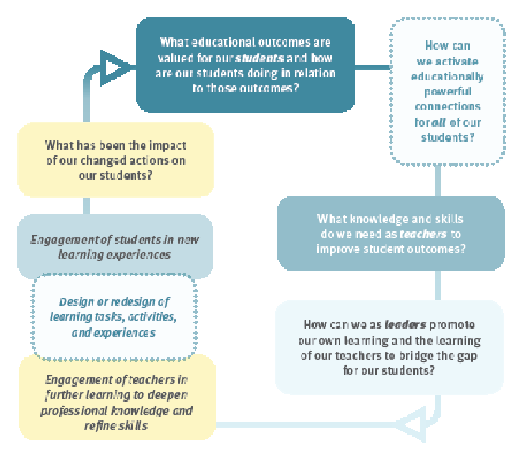

How are we ‘actively’ involving parents, family and whanau in students LEARNING?

Engage in deep constructive talk - unpack both the impact of their practice on student learning and the beliefs, values and assumptions that uderpin practice.

Reflect on the impact of their literacy practice to accelerate focus student’s writing, and identify the practices they need to REFINE, DEVELOP or DISCARD

Consider innovative or different ways to support students that are currently underachieving or disengaged with learning.

Model for Evidence-informed conversations - see venn diagram

Joan Dalton’s books - Learning Talk - conversations with staff/parents

Building Relational Trust!!

Share my learning journey - eg. as an instructional leader.

PLG - Group Agreement -

* suspending judgement,
* identifying assumptions,
* listening,
* inquiring and reflecting.

**Coaching and Mentoring**

The differences - see hand out for details.

**SCARF Model and Developing an Inquiry Culture**

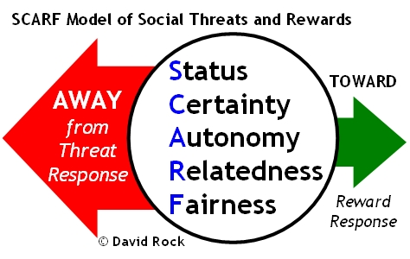

Think about people’s stress levels - consider the SCARF model when working with others.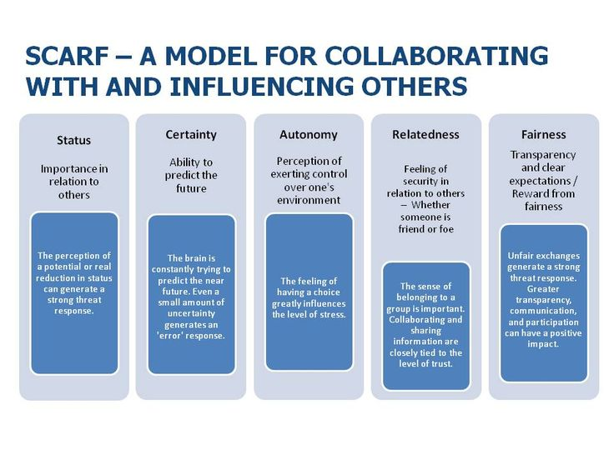

**Status** - can come across in all sorts of way - eg. talking down to people, I’m better than you attitude.

**Certainty** - many people need to know the absolutes about everything, others don’t.

**Autonomy** - some teachers need places for them to have choice, others don’t want too much choice. “Okay let’s try your way”, Does anyone else want to try that way? Let’s give it a try.

**Relatedness** - feeling like you have something to share, or are you on the outer? How are they perceived in what we are doing? Do they feel a sense of belonging?

**Fairness** - some people need more feedback than others - rewards, communication, conversations, have they got choices?

**Effective Mentors shift from Knowing to Inquiring - be a mindful mentor**

Remember the **Ladder of Inference** - Observe, Select, Meanings, Assumptions, Conclusions, Beliefs, Action

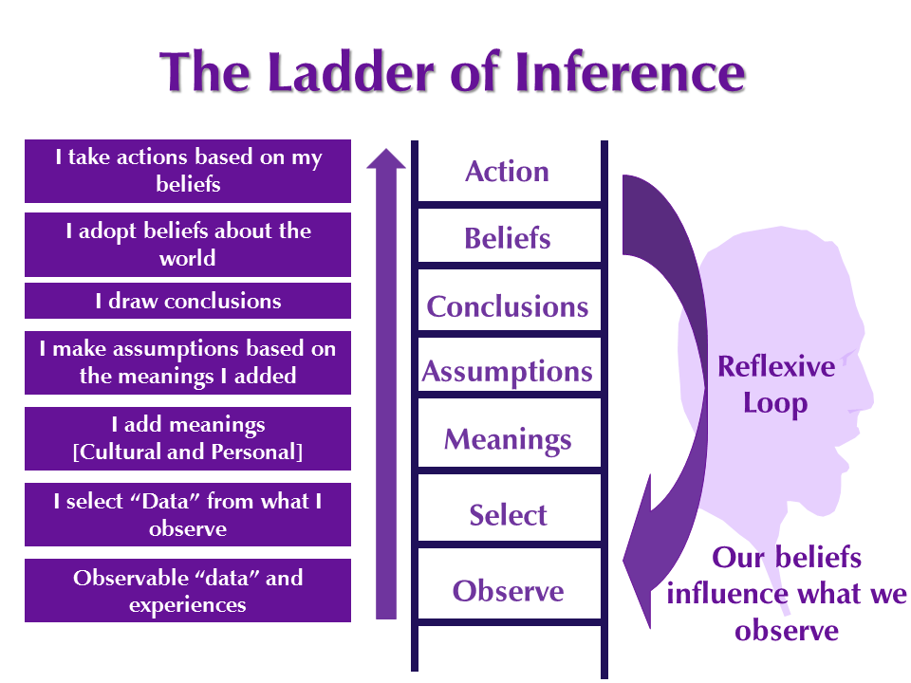

**Coaching and Mentoring Scenarios**

**Pattern of Inquiry**

**Listen - Pause - Paraphrase - Inquire - Decide a Plan**

________________________________________________________________________________________

**Literacy and Middle Leader Workshop Series - Workshop 1**

Colleen Wills - 21.3.16

Sustained acceleration - look at the roles of everyone; distributed leadership

Leadership Capabilities for Evidenced Based Inquiry

|  |  |  |
| --- | --- | --- |
| **Organisational Capability**  *The capacity to effect change. Capable school have strong integrated and well understood systems.* | **Instructional Capability**  *Teachers know and use practices that are effective for all students. Teacher have the key role in building caring, inclusive learning communities in their classrooms. Leaders use strategies to support teachers to rigorously inquire into the impact of their practice.* | **Evaluative Capability**  *Evaluate the impact of changes and outcomes for students. This involves the purposeful gathering, analysis and use of student achievement data and other forms of data.* |
|  |  |  |

**BES** - best evidence synthesis

Middle Leaders are Pivotal Change Agents - shape innovation and lead change in schools.

Helen Timperley - Organisational Capability; Instructional Capability; Evaluative Capability. Towards an Optimal model for building better school. About connecting all the ‘bits’.

How do leaders support teachers to change their practice?

**Effective Leader Attributes:**

Growth Mindset

Vision

Relationships

Use the strengths from within a team/school

High expectations

Clear, transparent systems

Believing that all teachers are capable of teaching well - mentor our teachers

Relationships that will develop teaching knowledge.

Keep the students at the heart of the learning. Some new leaders find it difficult to find their place - still want to be one of the girls etc

**The Educational Leadership Model**

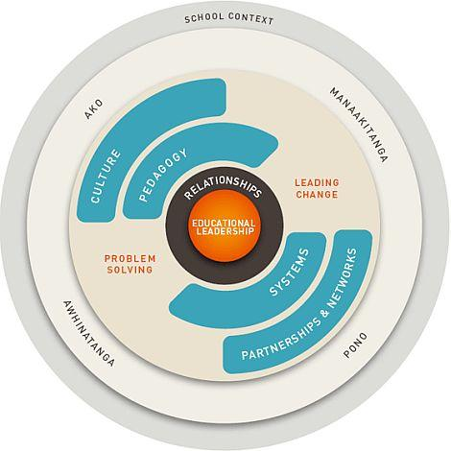

Need a mix of both leaderships styles. Vision is important … but take this to the next level - instructional leaders role.

|  |  |
| --- | --- |
| **Instructional Leaders** | **Transformational Leader** |
| Worry about the impact that the adults are having on the students - is the impact good enough, look at data etc. Discussions, PD, how do we know we are having an impact?  *Scheduled times for discussions*  *Teacher talk that makes the difference.*  0.6 effect for instructional leaders  5-10% of leaders are Instructional Leaders  What mindset does the principal have?  Are we having an impact?  Is it worthwhile?  Is it working? Is it sufficient?  A lot harder than having a shared vision.  Find different ways to teach different kids.  Giving teachers different strategies. About the teaching!!! Having discussions.  *What is it that effective teachers are doing all the time? What are the high impact pedagogies that are making the difference.*  It is about teaching, not the resources etc.  Identifying in defensible ways when high impact is happening. And being prepared to back it!!  Evidence in dependable ways.  Teachers who are open to change, reflective  Will never get 100%  When is good enough? 20%, 40%?  Move from ‘can we?’ … To ... ‘how can we?’ | Business notion from 1970s  Lead schools around a common vision - teachers, students etc.  Aspirational visions  .15% effect for transformational leaders  Principal's belief/role - lead change agent  There job is more with the teachers not the students. |

**Leaders as Change Agents …**

4 Levers for Change and Acceleration - what are we doing to support teachers to be able to accelerate learning? Put this onto a big page and brainstorm ideas for each quadrant.

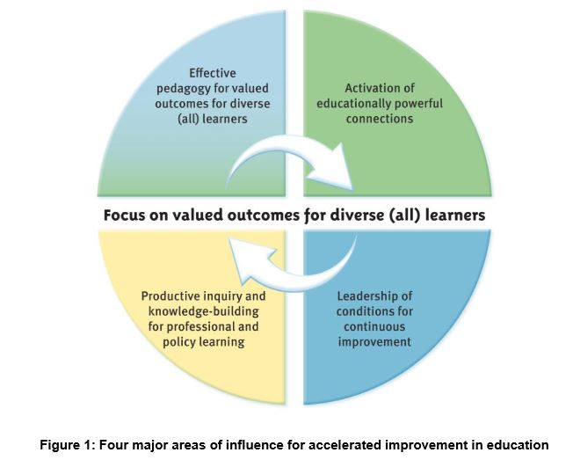

These 4 levers were identified through BES research, that when used together, support improved outcomes for diverse learners.

**What is Acceleration?**

If child 1 year behind … can take up to 2 years to catch up

Children 2 years behind … often never catch up!!!

It has 3 dimensions …

**Teaching As Inquiry**

* Collaborative process
  + PLG - professional Learning Group
  + PRG - professional Research Group
    - Discussions - we think everyone is on the same page … but in fact we may not be!
    - Making the connections
* Culture of Inquiry - we don’t ‘do’ inquiry

Determine agreed ways of working together when discussing inquiry.

Set the ground rules.

**PLG Discussion - a possible framework:**

* Each teacher given 10 minutes to talk - dump (uninterrupted by other people)
* Tracking Sheet to be brought to each meeting (updated etc. - Sally’s idea - goals, dates, etc.)
* Teachers to bring evidence of strategies I’ve been using
* Discuss what I’ve been doing
* What will I throw away? - not working
* What will I keep?
* What will I refine?
* Then discussion opened to the floor/group to add advice/share strategies etc. Feedback/Feedforward in a safe environment where everyone’s ideas are valued, respected and listened to. Where questions are okay.

**Literacy Intervention Success**

All Talk - non school talk

School Talk - non-teaching practices talk

Teaching practices talk - non learning talk

Deep constructive Learning Talk

* Analytical talk
* Critical talk
* Challenging (change) talk

What talk is useful to raise achievement? A focus on deep constructive talk

**Quality Teaching and Learning Pedagogy**

**Vision**

**Values/Learner Qualities**

**Key Principles**

**Student Progress/Achievement (progressions)**

**Collaboration (TK Way) - Flexible/Purposeful Space**

**Research/Professional Learning - EPIC - Personal Action Plan (Inquiry)**

**My Portfolio (where evidence of the above is captured)**

**Teacher Appraisals**

**Learner Focused Evaluation Processes and Reasoning**

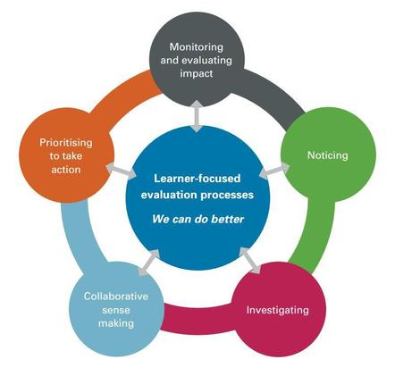

**Papamoa Primary School - video**

How urgently are we expecting progress with our students?

What are our reading programmes looking like?

Develop content knowledge of teachers.

What’s our sense of urgency??

Easy to slip into the mode of children working at ‘their own pace’.

Observations

In depth dialogue

Video recordings

What data are we collecting?

How urgent our actions are?

How long are we allowing children to work at a level?

What makes a difference in a Junior Classroom

Systems, processes and DATs

Build structure about how to promote the talk and dialogue of shifting students progress/achievement

Targeted action plan

Names to faces

Identify priority learners

What have I tried? What do I need support and help with now?

Check for regular movement!!!

A way of meeting the needs of the children in our space - not another thing. It’s our core business.

Targeted action plans - recognise what aspect of the learning is a learning challenge

Explicit needs/challenges. What will we do to meet these challenges.

Teachers need to be open to change

Prepared to research

Also prepared to admit I don’t know what to do.

The language we used changed - inquiry, data as evidence, who else can help me/us?

Intense focus!

Develop sense of urgency!

Constantly using our data - look at what the information tells us!

Changed our talk and expectations

Used each other as a support network

**Spirals of Inquiry**

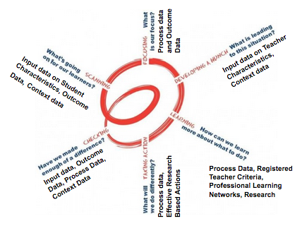

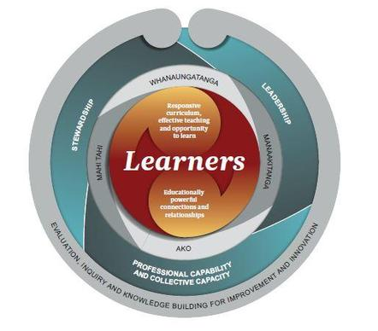

**Learning in the Fast Lane - book - Suzy Pepper Rollins**



**Read, Write, Lead (Regie Routman)**

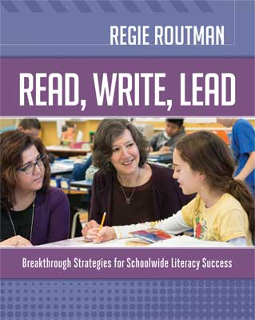

Learning Talk (Joan Dalton)

